THE UGANDA INTERGOVERNMENTAL FISCAL TRANSFERS (UGIFT)
REPORT ON THE FINDINGS OF HEALTH CENTERS AND SCHOOLS IN PAKWACH DISTRICT – WEST NILE REGION
Date: 4th September, 2026
Preamble
This report details the field monitoring and asset verification exercise conducted for local government educational infrastructure under the Uganda Intergovernmental Fiscal Transfers (UgIFT) program. Recognizing the vital role of transparent asset management in service delivery, this assessment evaluates the procurement, delivery and functionality of assets at Todora H/C, Paraa H/C, Got Apwoyo H/C, Koch Lii H/C III, Got Apwoyo and Lungulu Seed Secondary Schools in Nwoya District. Facilitated by the coordination of the CAO, DEO, DHO, local district finance department, Health facilities’ in-charges and the schools’ head teachers, this document presents key findings, accountability structures, challenges and technical recommendations to optimize district educational resources

- GOT APWOYO SEED SECONDARY SCHOOL NWOYA DISTRICT LOCAL GOVERNMENT
Executive Summary
This report presents the field audit findings and comprehensive physical asset inventory for Got Apwoyo Seed Secondary School, located in Got Apwoyo Sub-County, Nwoya District Local Government, executed under the Uganda Intergovernmental Fiscal Transfers (UgIFT) Programme.
Got Apwoyo Seed Secondary School is currently under construction and has not yet been commissioned. While civil construction will significantly improve secondary education access in Got Apwoyo Sub-County, construction delays have completely stalled program rollout. Consequently, all delivered furniture items and civil structures are uncommissioned and classified as non-functional, while the entire ICT equipment package (20 computers, server processor, network switches, printer, UPS units, projector, ACs, CCTV, firewall, routers, and LAN) remains stored at Nwoya District headquarters awaiting facility completion.
Field Findings
- Facility construction status: All primary structures (3 classroom blocks, administration block, main hall, science lab, ICT lab/library, staff quarters, pit latrines, water tanks) remain under ongoing construction and uncommissioned.
- ICT assets retained at district level: All ICT equipment categories—including 20 computers, server processor, 2 switches, printer, server UPS, 20 user UPS, projector, 2 ACs, CCTV, firewall, network rack, routers, LAN, and 12-month internet package—are currently held in Education department storage at Nwoya District headquarters.
- Uncommissioned school furniture: Delivered school desks, office tables, student chairs, office chairs, students' tables, and laboratory stools are on-site but non-functional due to ongoing site construction work.
Qualitative Assessment
Key findings from interviews with school administration regarding UgIFT program implementation, operational performance, maintenance protocols, and challenges:
Record Keeping
- No comprehensive asset logs capturing unit quantities and procurement unit costs at the facility the list were provided by the District Education department.
Repair & Maintenance
- Functionality logging: Functionality breakdown logs are not active as the school is not yet operational.
Educational Impact
- Academic transformation: The building structures, ICT lab, Library, classrooms, science labs, and staff quarters have created immense room for academic progress
- Distance reduction: Once completed, Got Apwoyo Seed SS will dramatically reduce walking distances for rural students and enhance secondary school enrollment.
Challenges
- Construction delay impact: Severe delays in civil works completion have prevented site commissioning and hindered the delivery/installation of computer hardware and laboratory apparatus.
Recommendations
- Urgent Civil Completion: Accelerating construction work is paramount to enabling facility commissioning, ICT installation, and school opening.
- Expedite civil works: Nwoya District Local Government and the Ministry of Education must enforce strict timelines for the contractor to finish civil works and hand over the school.
- Formal commissioning: Schedule formal facility commissioning upon structural handover to enable immediate academic operations.
Field photos
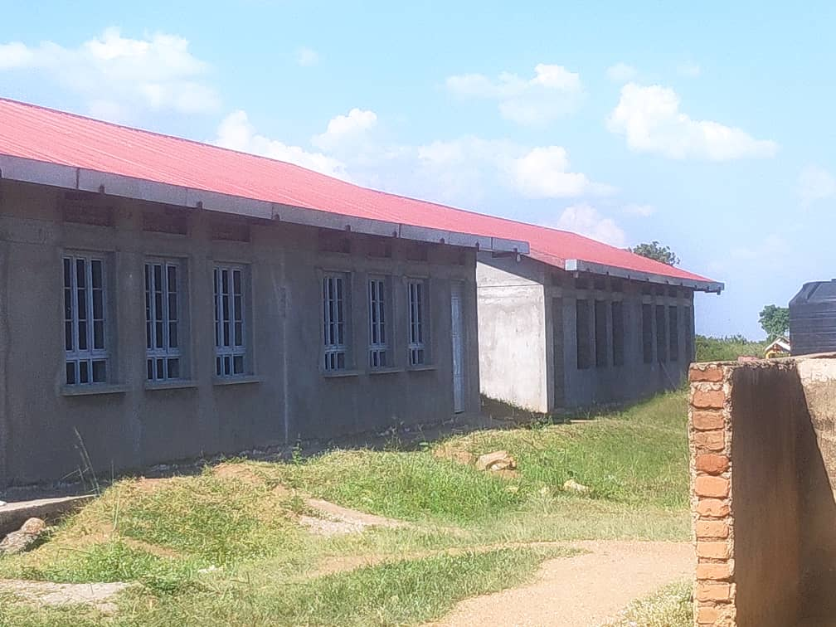
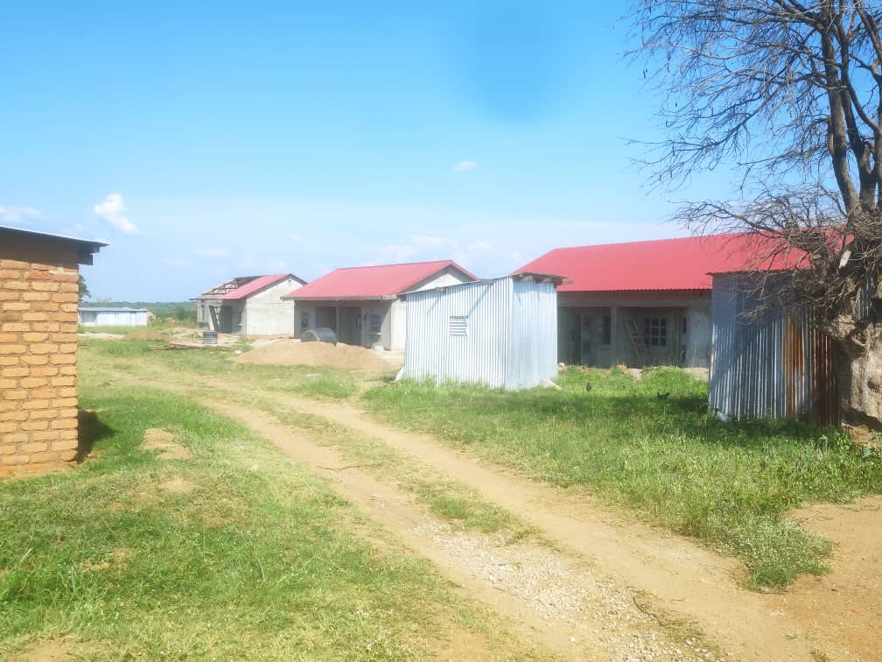

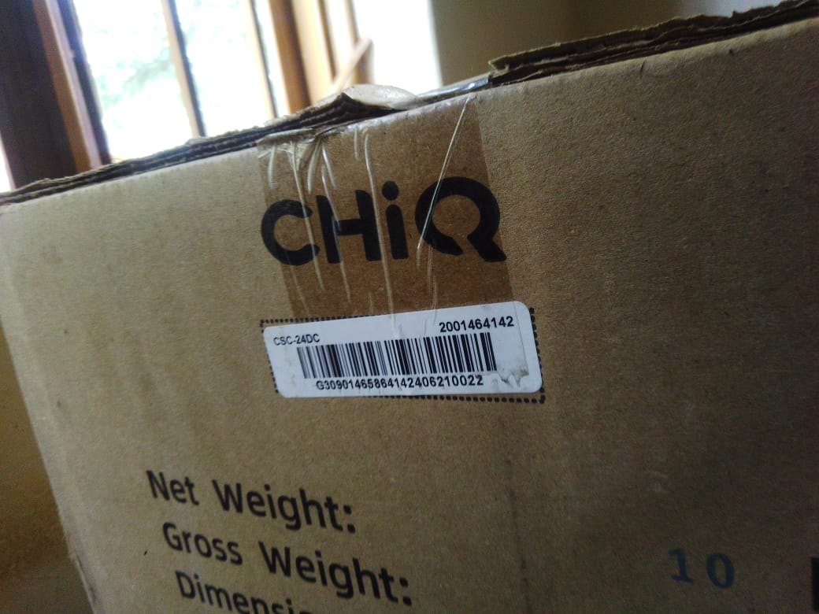
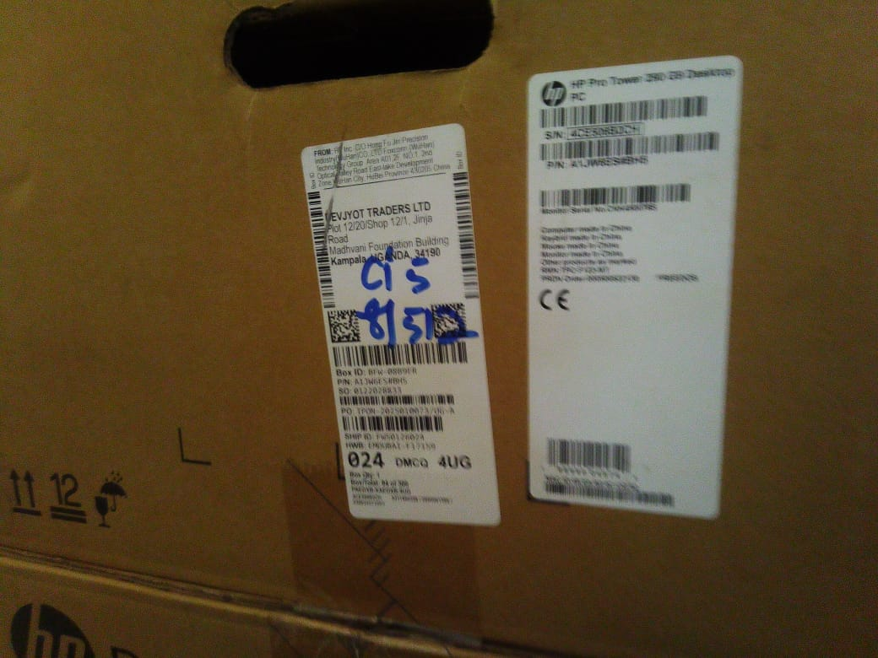

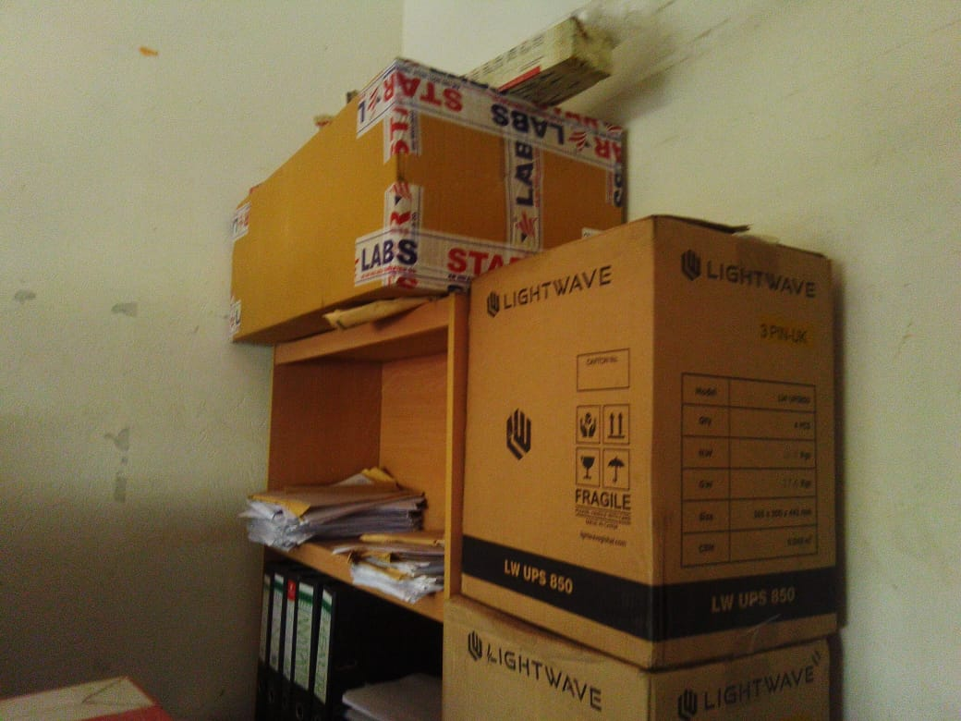
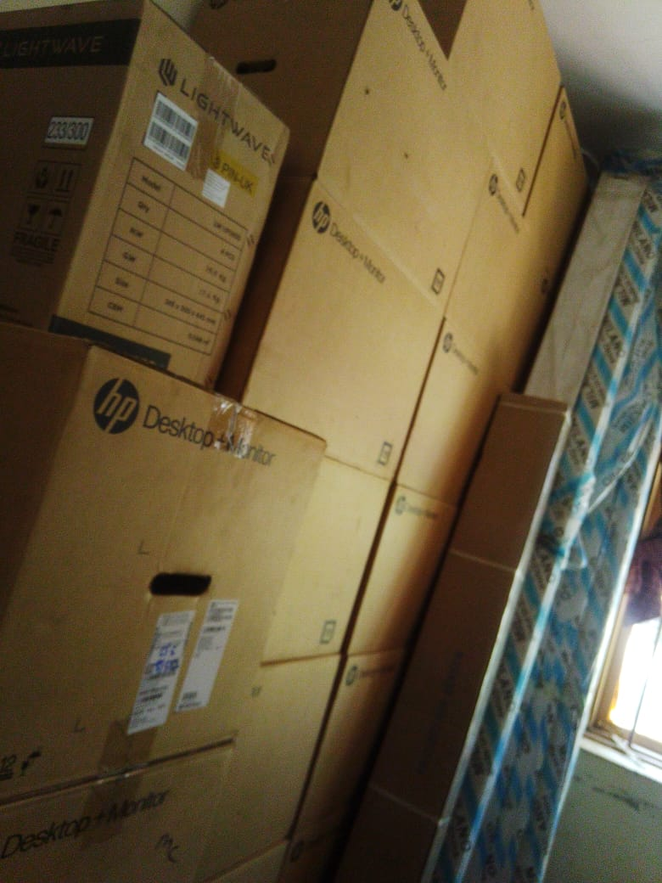

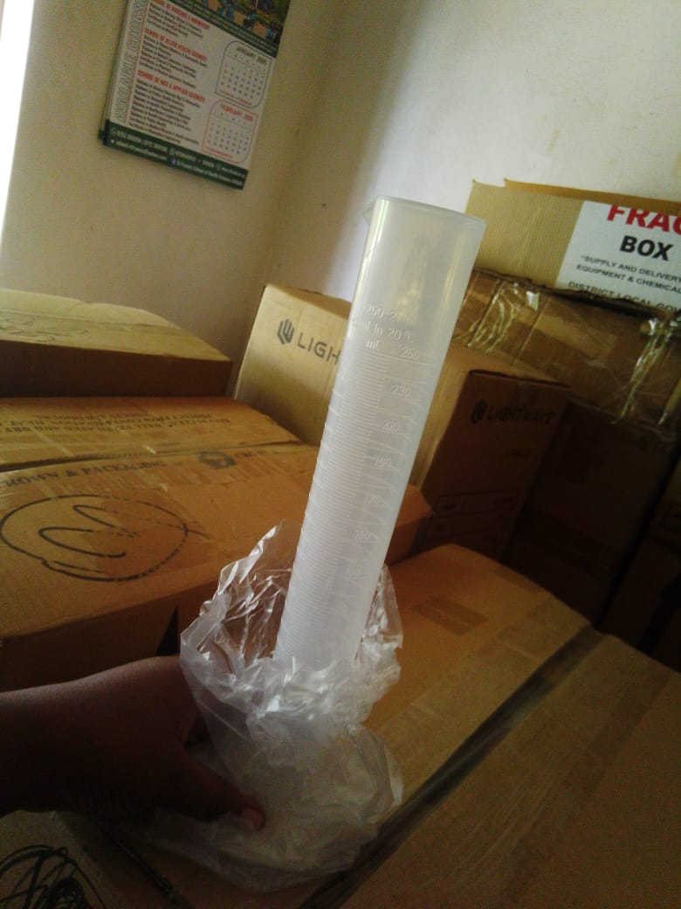

- LUNGULU SEED SECONDARY SCHOOL NWOYA DISTRICT LOCAL GOVERNMENT
Executive Summary
This report presents the field audit findings and comprehensive physical asset inventory for Lungulu Seed Secondary School, located in Lungulu Sub-County, Nwoya District Local Government, executed under the Uganda Intergovernmental Fiscal Transfers (UgIFT) Programme.
Lungulu Seed Secondary School has successfully expanded educational access in Nwoya District, accommodating large student enrollment and raising community academic standards. However, acute operational bottlenecks severely restrict facility utility: inadequate power supply has prevented the installation of delivered ICT assets (20 HP computers, 10 surge protectors, printer, and 20 UPS units remain stored in the school store), computers are defective, and there is an extreme deficit of laboratory stools (only 8 supplied). All the assets are not engraved.

Field Findings
- Civil infrastructure delivery: 3 classroom blocks (6 classrooms), 1 administration block, 1 multipurpose main hall, 1 science lab block, 1 ICT/library block (solar-equipped), 3 staff quarters, 4 pit latrines, and 3 water tanks delivered and in active use.
- Stored ict equipment (uninstalled due to power issue): 20 HP desktop computers, 10 power surge protectors, 1 multipurpose printer, and 20 user UPS units are stored in the school store awaiting power connection; 2 desktop units are defective.
- Severe ICT lab stool deficit: Only 8 laboratory stools were supplied to the school, severely constraining practical instruction for student cohorts.
Qualitative Assessment
Key findings from interviews with school administration regarding UgIFT program implementation, operational performance, maintenance protocols, and challenges:
Record Keeping
- Asset register absence: The facility lacks a comprehensive physical record of all assets supplied under the UgIFT program. No asset register on file at the school.
Repair and Maintenance
- Maintenance protocols: Minor maintenance is funded through internally generated school revenue, with DEO involvement for technical support.
- Breakdown tracking: Regular records regarding equipment functionality and breakdown status are maintained.
Program Impact
- Educational expansion: The new facilities have accommodated a significant surge in student enrollment and established high academic benchmarks in Lungulu Sub-County.
Challenges
- Power Grid Deficit: Severe electrical power limitations prevent the setup and operation of the computer laboratory, keeping ICT equipment stored.
- Laboratory Stool Shortage: Supply of only 8 laboratory stools is grossly insufficient for standard class sizes during science practicals.
- The school signpost has not been fixed since it broke which limits visibility and currently its kept at the school compound.
Recommendations
- Grid power extension: Coordinate with Nwoya District and Ministry of Education to extend stable electrical power to Lungulu Seed SS to enable ICT lab setup.
- ICT hardware setup & defect repair: Install the stored HP computers, surge protectors, printer, and UPS units once power is stabilized; repair/replace the 2 defective desktop computers.
- Support in fixing the signpost by the contractor
- Laboratory stool supply: Procure and deliver an additional cohort of laboratory stools (recommended minimum 66 stools) to meet the standard lab allocation of 74 stools.
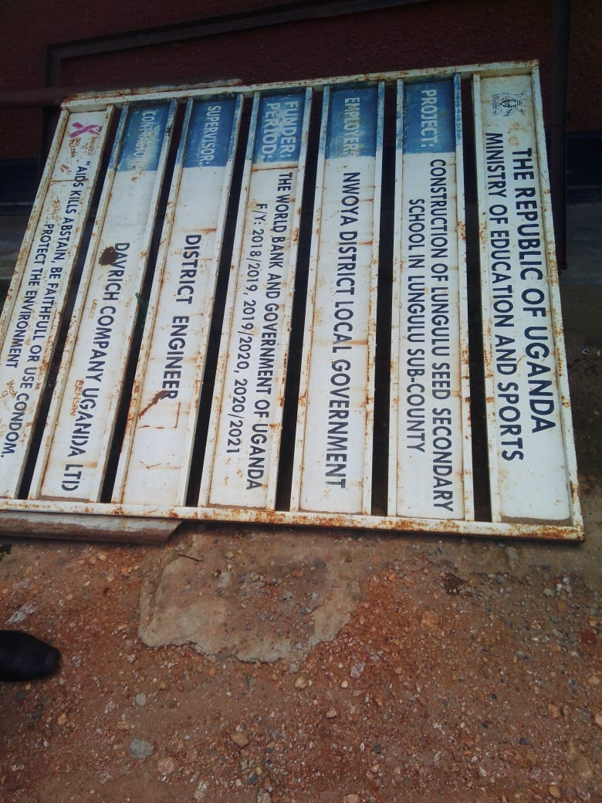
Field photos
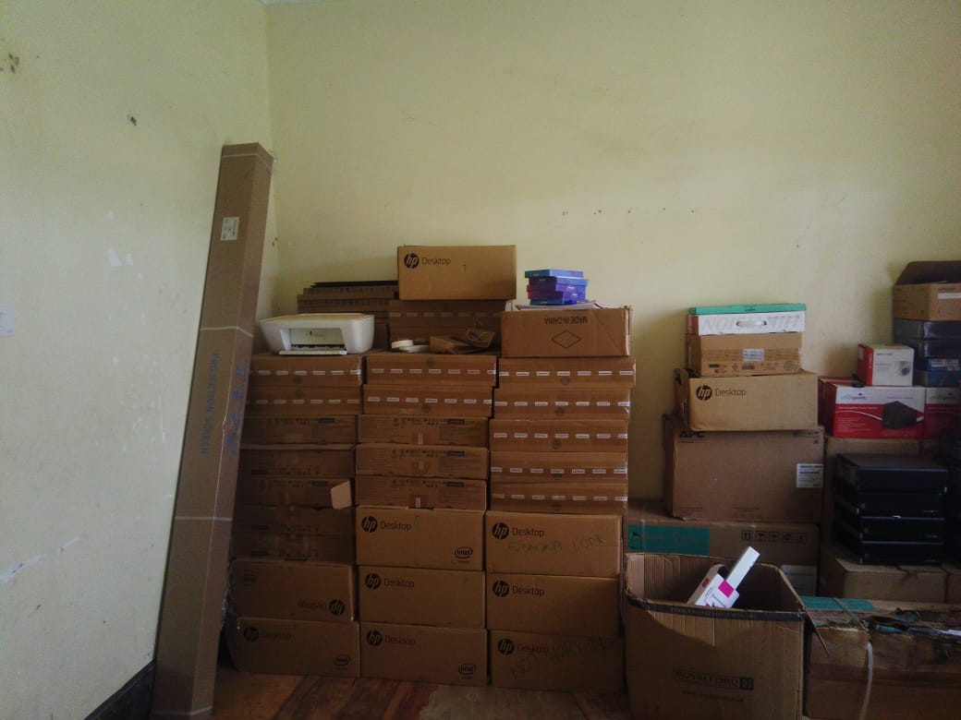

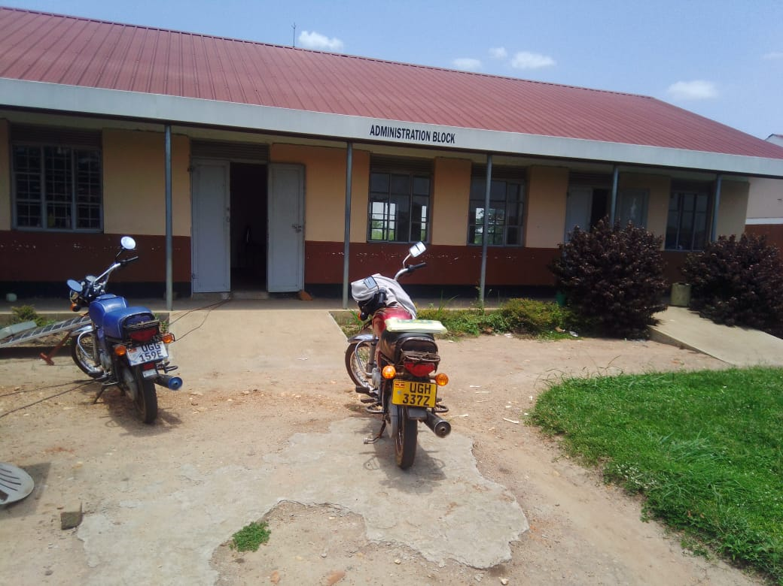
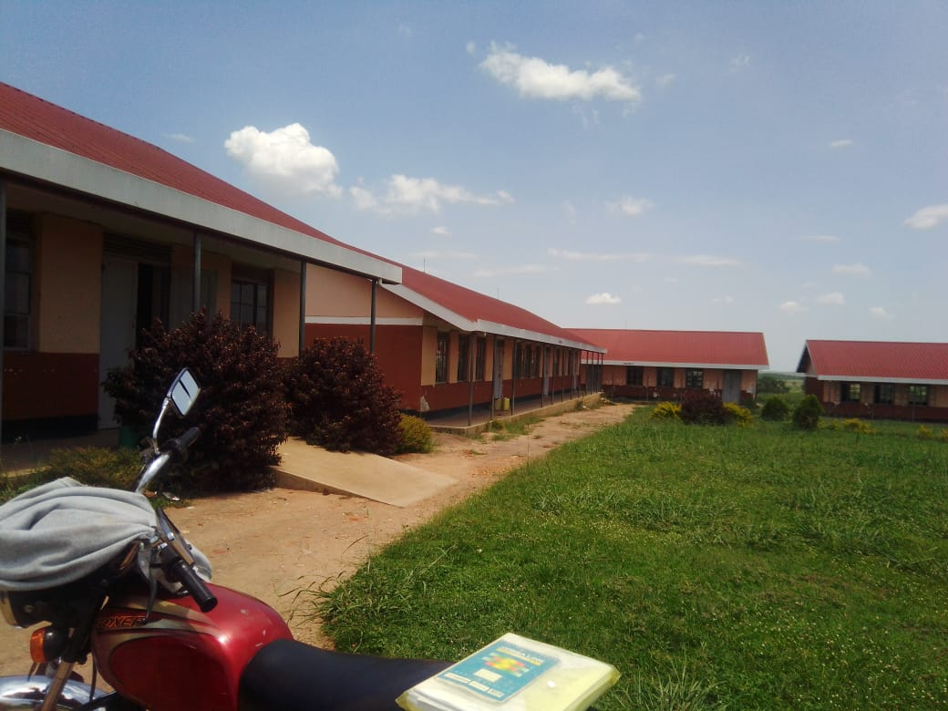

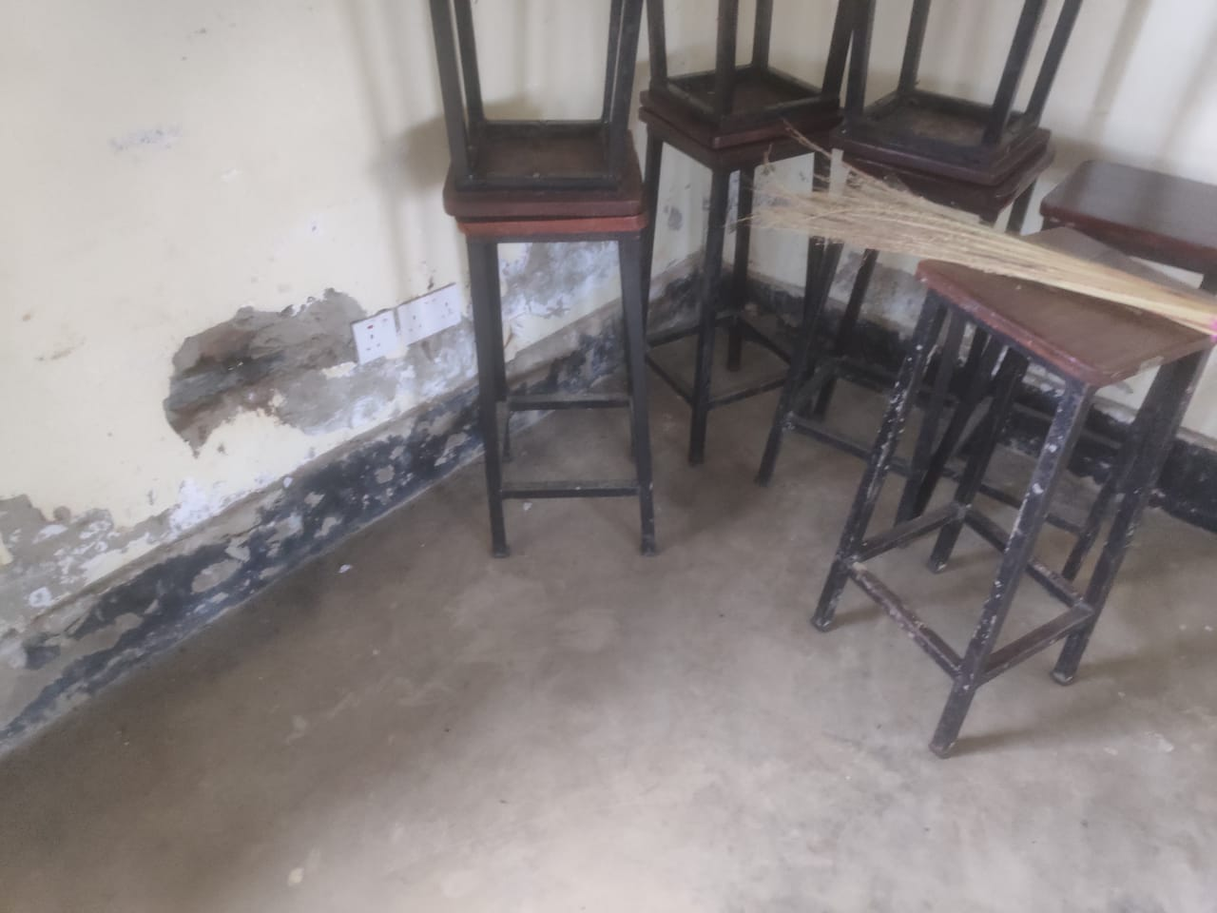
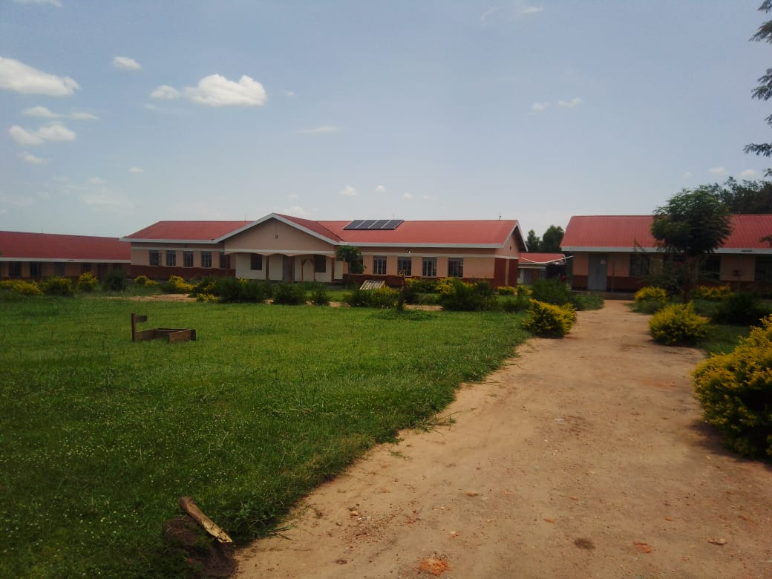

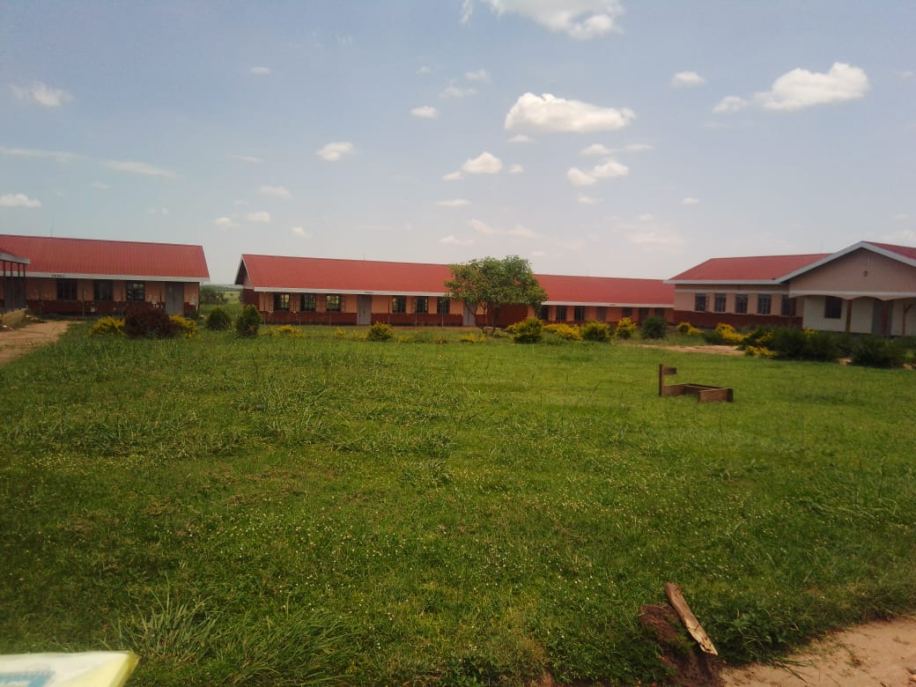
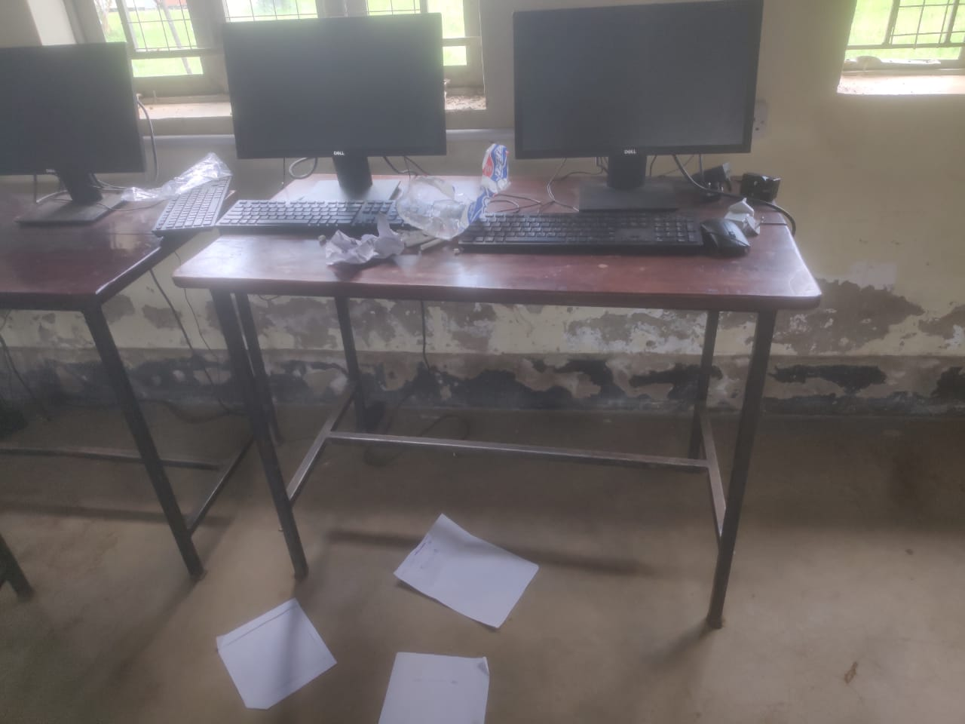

- TODORA HEALTH CENTRE III NWOYA DISTRICT LOCAL GOVERNMENT
Executive Summary
This report presents the field audit findings and verified physical asset inventory for Todora Health Centre III, located in Todora / Anaka Sub-County, Nwoya District Local Government, executed under the Uganda Intergovernmental Fiscal Transfers (UgIFT) Programme.
Todora Health Centre III is operational and has significantly improved primary healthcare delivery and patient trust in the community. However, a major inter-facility asset transfer issue exists: because Todora HC III was under construction during initial UgIFT equipment distribution, a substantial batch of its designated UgIFT assets was redirected to Paraa HC III (which was already functional). Consequently, Todora HC III has not yet retrieved/received all of these assets. Furthermore, 3 out of 5 wheelchairs are defective (lacking rubber on wheels), and staff housing is insufficient.

Field Findings
- The main building structures are in good condition and fully functional that is the OPD, In-patient, Maternity and offices (Civil Buildings & Sanitation)
- Most of the available medical equipment, and laboratory instruments are functional.
- Inter-facility asset redirection: Assets originally designated for Todora HC III were delivered to Paraa HC III during Todora's construction phase and have not been fully transferred back.
- No office chairs were delivered however 14 plastic chairs were delivered to the facility
- Equipment defects: 3 out of 5 wheelchair units are only partly functional due to missing rubber tires/rim padding.
- Staff accommodation constraints: Current staff quarters are insufficient to house the required healthcare workforce on-site, impacting night/emergency coverage.
- All assets are not engraved
Qualitative Assessment
Key findings from interviews with health facility in-charges regarding UgIFT program implementation, asset maintenance, operational impact, and service bottlenecks:
Record keeping
- Has asset records on file at the facility.
Repair and maintenance
- Regional maintenance schedule: Major medical machinery maintenance is managed by the Gulu Regional Referral Hospital technical team according to their regional itinerary.
- Breakdown reporting: Regular breakdown logs are maintained by facility staff and escalated to the DHO and technical team.
Service Delivery Impact
- Primary health expansion: Modern medical equipment has significantly increased patient volume and improved maternal and child health services in the community.
- Operational utility & community trust: Medical equipment and facilities in use have boosted outpatient/inpatient admissions and community confidence in local healthcare delivery.

Challenges
- Asset transfer issue: Assets assigned under UgIFT were temporarily handed over to Paraa HC III during construction, creating inventory gaps at Todora HC III.
- Housing requirement: Facility management strongly recommends the construction of additional staff quarters to improve staff retention and emergency response.
Recommendations
- Reconcile assets with Paraa HC III: Nwoya DHO should audit and facilitate the formal transfer of all Todora HC III's UgIFT asset allocation from Paraa HC III without incurring transport costs as the facility has to use its own money to facilitate for the transportation of these assets.
- Asset ledger audit: Update Todora HC III's physical asset register to reflect reconciled items.
- Wheelchair Repair: Replace wheel rubber/tires on the 3 defective wheelchairs to restore 100% mobility support.
- Staff quarters construction: Prioritize funding for additional staff housing units in upcoming UgIFT/DLG capital budget cycles.

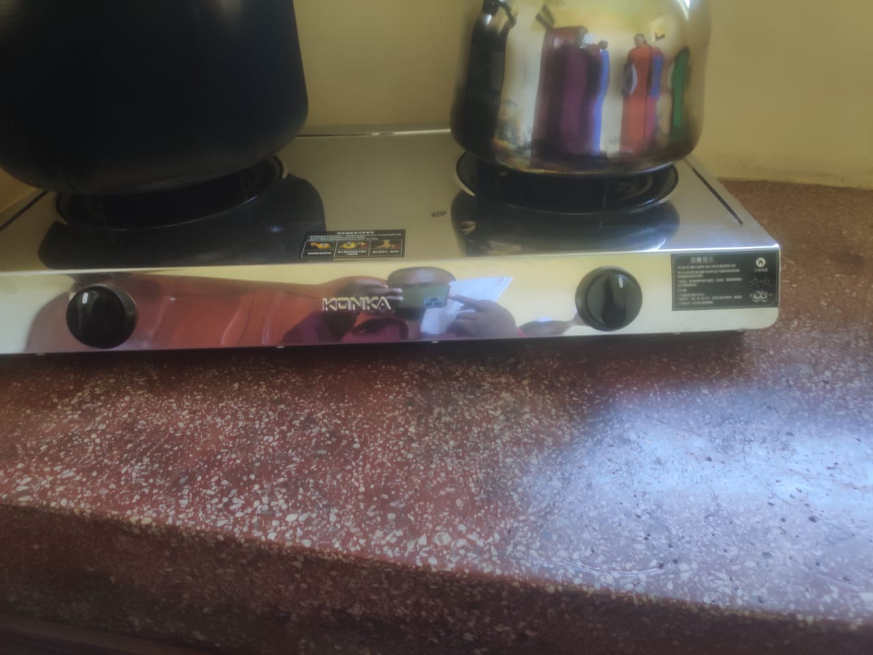
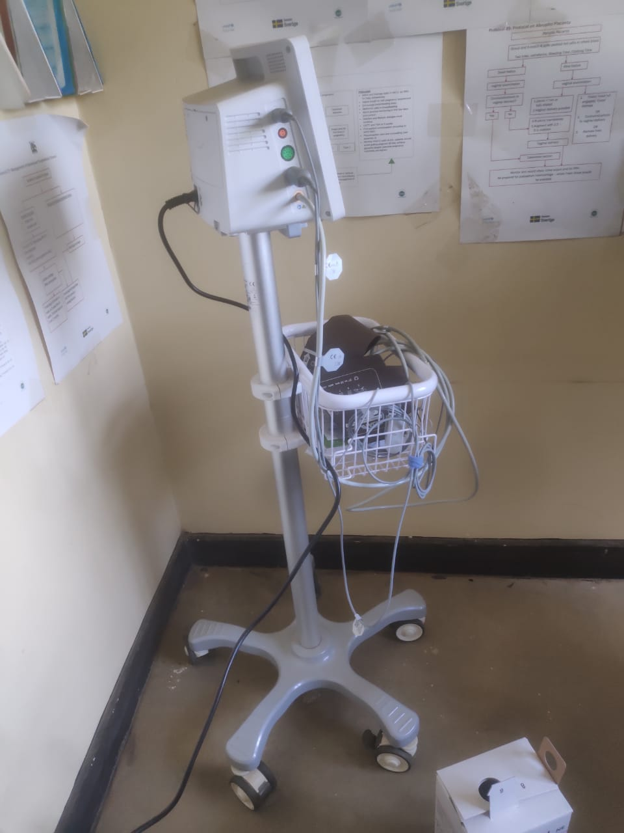
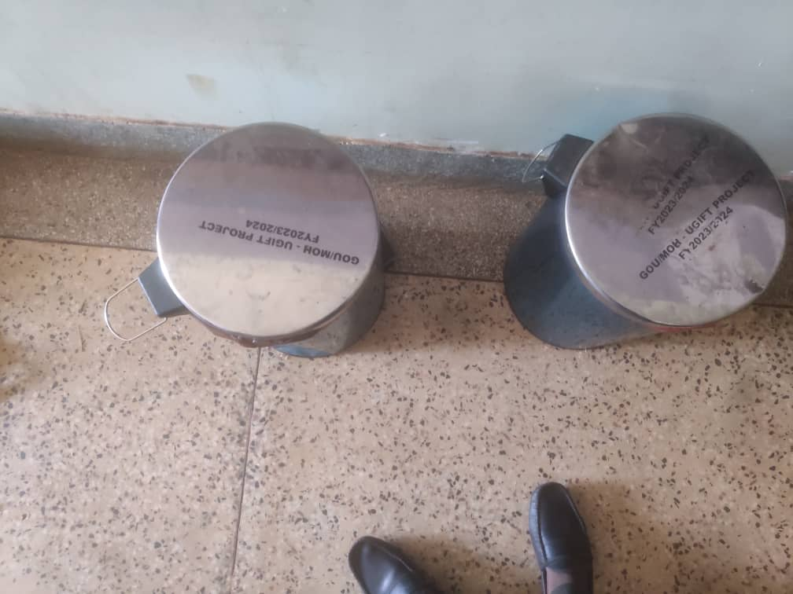
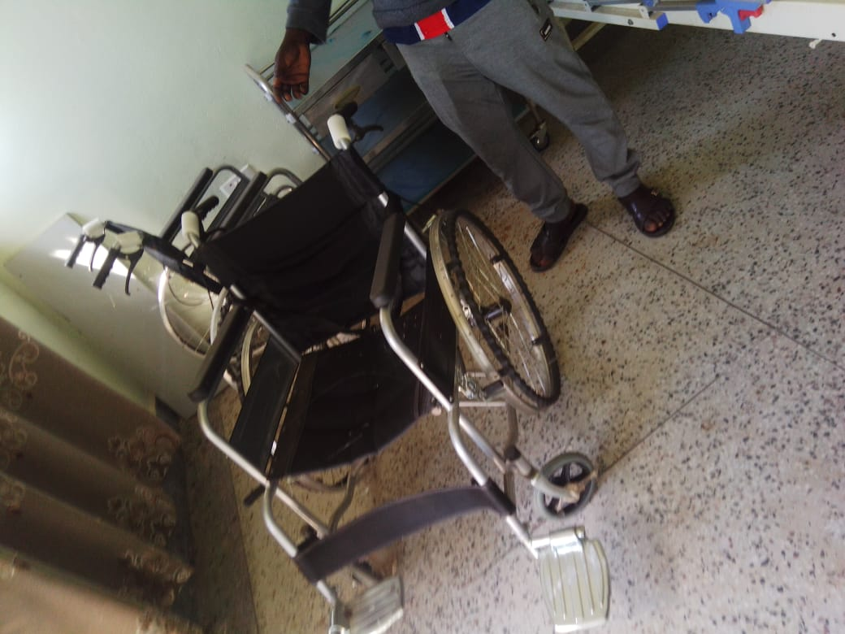
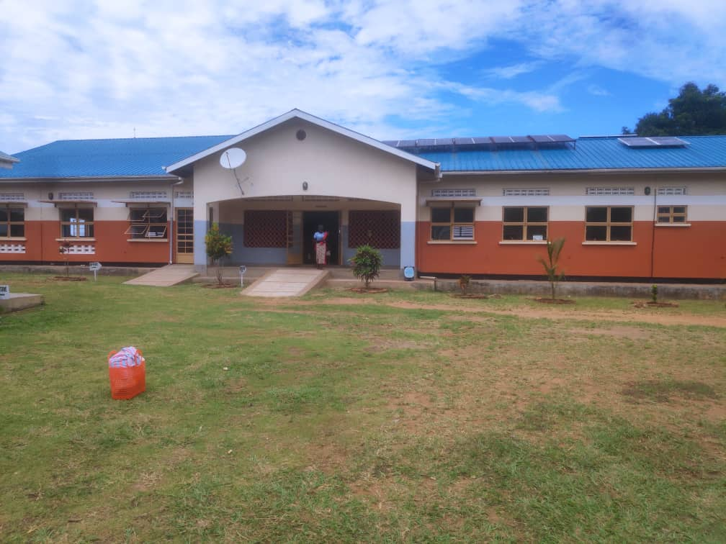

- PARAA HEALTH CENTRE III NWOYA DISTRICT LOCAL GOVERNMENT
Executive Summary
This report presents the field audit findings and verified physical asset inventory for Paraa Health Centre III, located in Purongo Sub-County, Nwoya District Local Government, executed under the Uganda Intergovernmental Fiscal Transfers (UgIFT) Programme.
Paraa Health Centre III is highly operational and well-supplied, benefiting from both its primary UgIFT asset allocation and additional UgIFT equipment temporarily redirected to it during Todora HC III's construction phase. While service delivery and referral management have improved greatly, the facility faces operational challenges including power instability and staff knowledge gaps regarding certain complex machinery.
Field Findings
- The main building structures are in good condition and fully functional that is the OPD, In-patient, Maternity and offices (Civil Buildings & Sanitation)
- Most of the available medical equipment, and laboratory instruments are functional.
- All assets are not engraved
- Expanded asset base: Paraa HC III holds an extended asset portfolio as it received Todora HC III's asset allocation during Todora's construction phase.
- Improved service delivery: Modern clinical gear has enhanced diagnostic precision, reduced emergency referrals, and boosted patient turnout.
Qualitative Assessment
Key findings from interviews with health facility in-charges regarding UgIFT program implementation, asset maintenance, operational impact, and service bottlenecks:
Service Delivery Impact
- Primary health expansion: Modern medical equipment has significantly increased patient volume and improved maternal and child health services in the community.
- Operational utility & community trust: Medical equipment and facilities in use have boosted outpatient/inpatient admissions and community confidence in local healthcare delivery.
Repair and maintenance
- Maintenance escalation: Breakdowns are reported to CAO, DHO, and Gulu Regional Referral Hospital maintenance engineers for scheduled servicing.
Challenges
- Electrical fluctuation: Unstable electricity hampers continuous operation of electric assets
- Staff training deficit: Clinical personnel require refreshed training on advanced neonatal and surgical diagnostic equipment.
Recommendations
- Solar / Inverter Setup: Install reliable power backups and surge protectors for electric machines.
- Technical training: Conduct refresher orientation workshops on specialized machinery operation for healthcare workers.
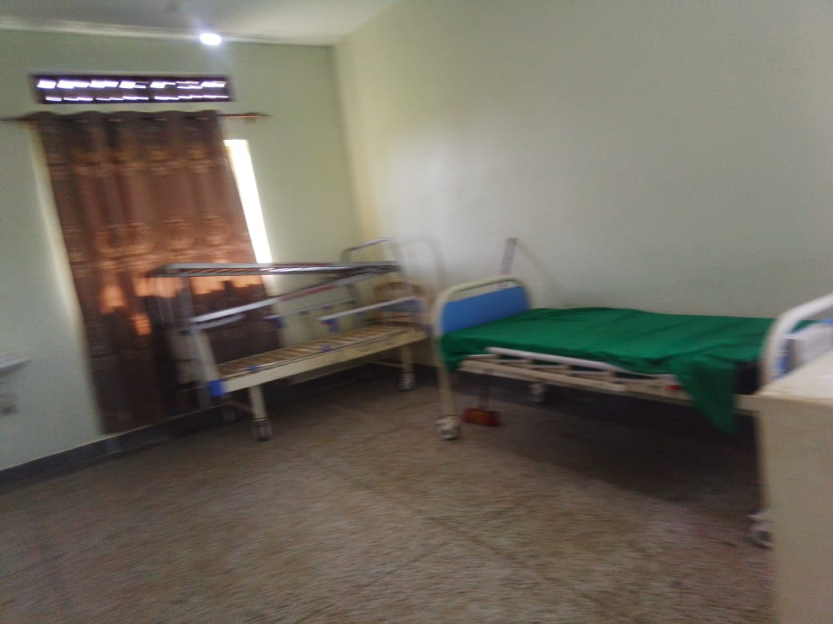
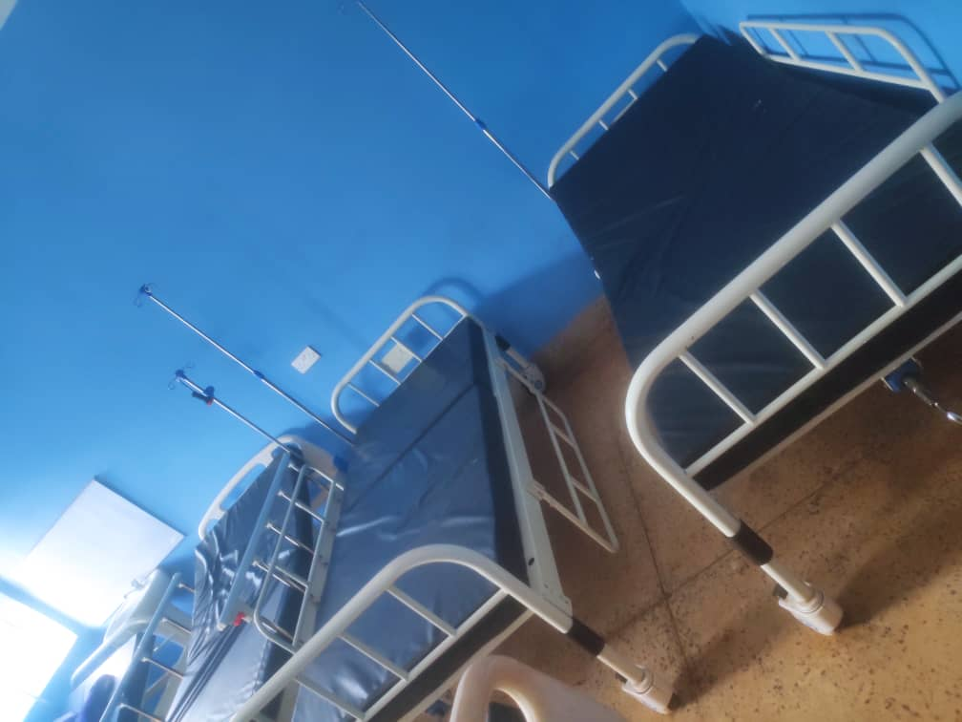

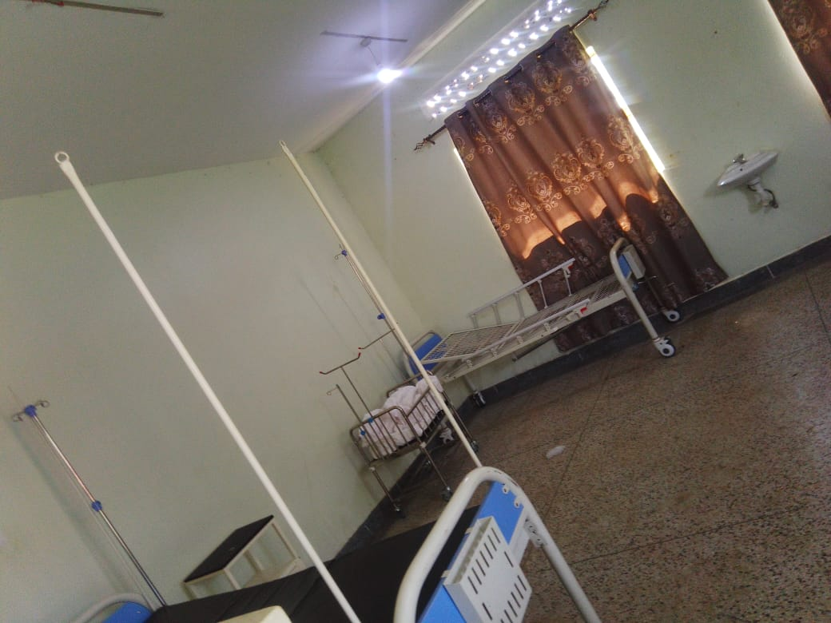
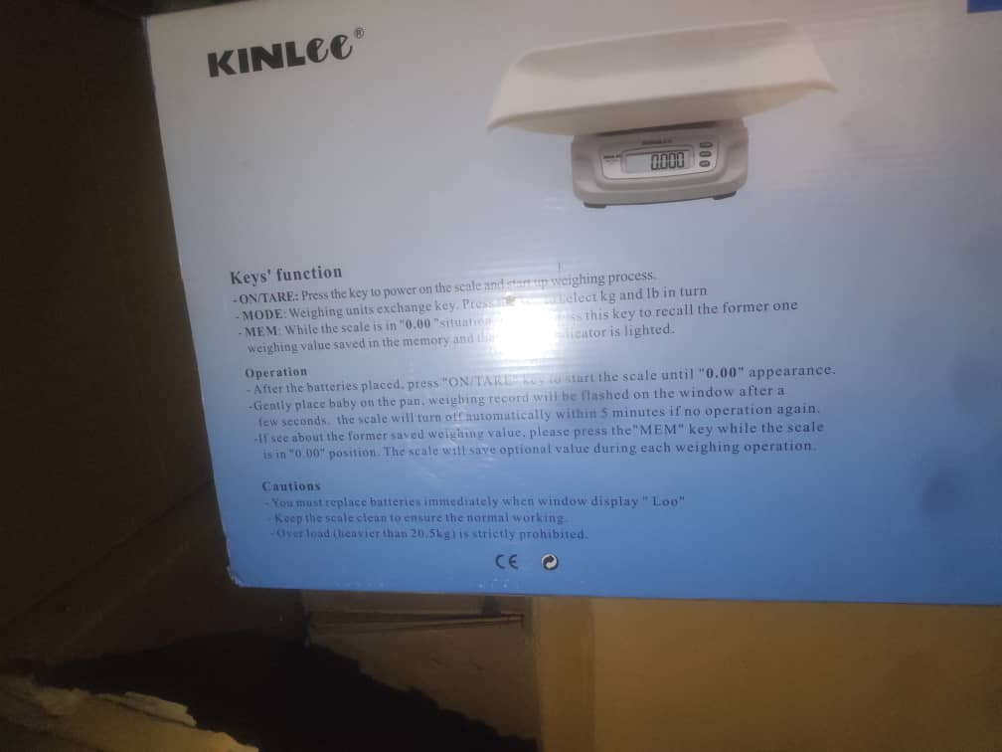

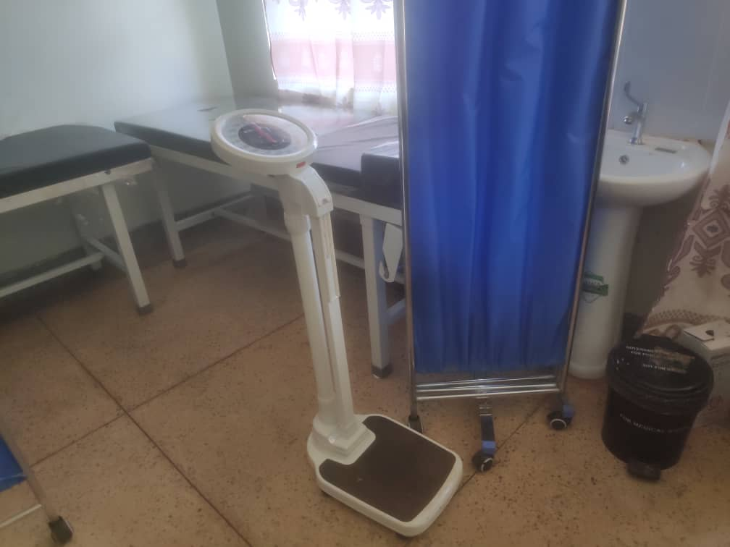
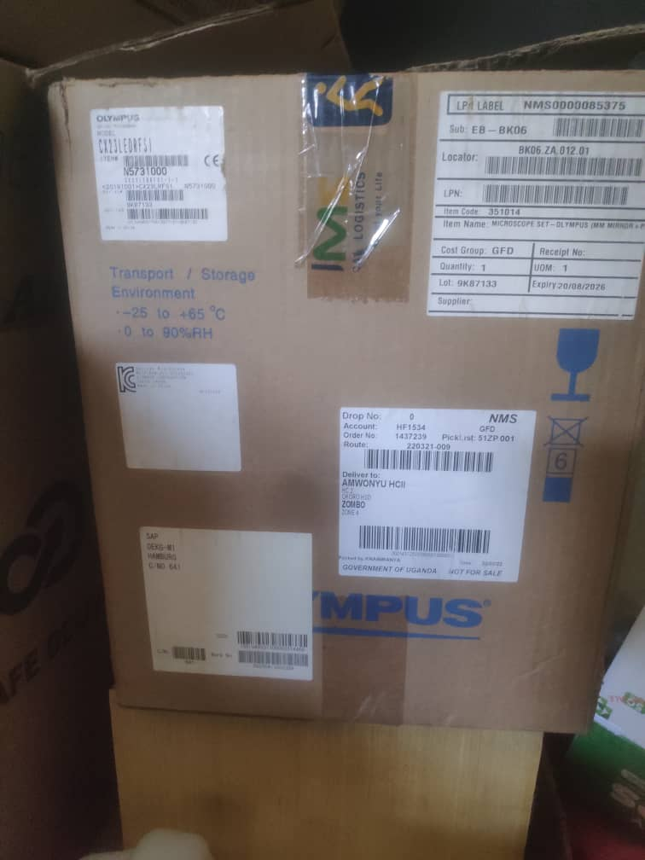
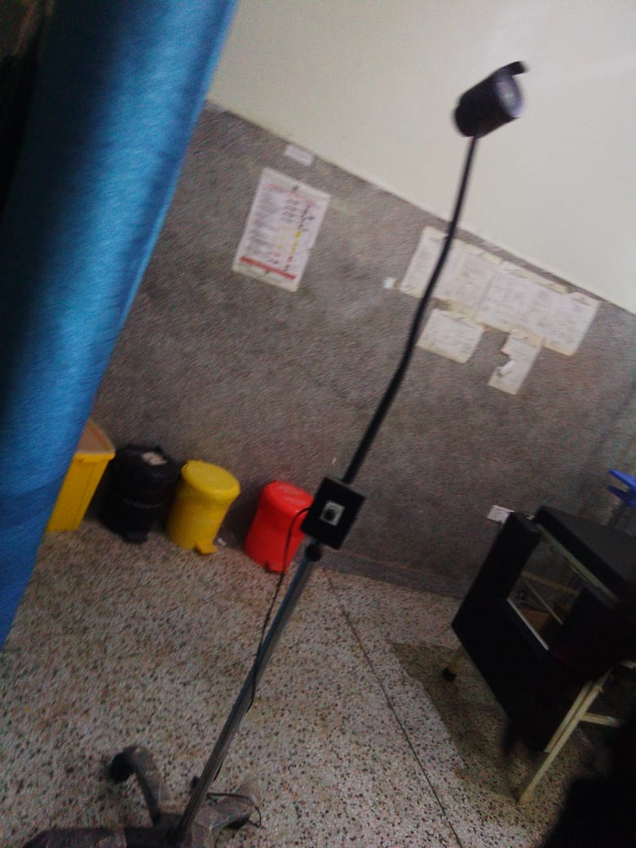

- KOCH LII HEALTH CENTRE III NWOYA DISTRICT LOCAL GOVERNMENT
Executive Summary
This report presents the field audit findings and verified physical asset inventory for Koch Lii Health Centre III, located in Koch Lii Sub-County, Nwoya District Local Government, executed under the Uganda Intergovernmental Fiscal Transfers (UgIFT) Programme.
Koch Lii Health Centre III is fully operational and well-equipped, resulting in higher patient turnout and strong community confidence. However, electrical power supply instability is a critical bottleneck, leaving several power-dependent medical devices unutilized including the oxygen therapy apparatus/oxygen machine.
Field Findings
- The main building structures are in good condition and fully functional that is the OPD, In-patient, Maternity and offices (Civil Buildings & Sanitation)
- Most of the available medical equipment, and laboratory instruments are functional.
- All assets are not engraved
- Improved service delivery: Modern clinical gear has enhanced diagnostic precision, reduced emergency referrals, and boosted patient turnout.
- Operational expansion: Community trust and patient volume have increased markedly due to the comprehensive delivery of diagnostic and maternal equipment.
Qualitative Assessment
Key findings from interviews with health facility in-charges regarding UgIFT program implementation, asset maintenance, operational impact, and service bottlenecks:
The asset register maintained at the facility captures item quantities but lacks unit purchase costs.
Service Delivery Impact
- Primary health expansion: Modern medical equipment has significantly increased patient volume and improved maternal and child health services in the community.
- Operational utility & community trust: Medical equipment and facilities in use have boosted outpatient/inpatient admissions and community confidence in local healthcare delivery.
Record keeping
- Incomplete asset ledger: The facility ledger lists delivered item quantities accurately but lacks financial purchase values.
Repair and maintenance
- Maintenance escalation: Breakdowns are reported to CAO, DHO, and Gulu Regional Referral Hospital maintenance engineers for scheduled servicing.
- Escalation to DHO: Equipment breakdown logs are updated regularly and submitted to the District Health Officer and Gulu RRH engineers.
Challenges
- Unreliable electricity: Power fluctuations disrupt daily clinical workflows and prohibit the deployment of electric medical machinery.
- Underutilized oxygen equipment: Oxygen delivery devices are idle during outages, posing risks to critical respiratory patients.
- Staff training deficit: Clinical personnel require refreshed training on advanced neonatal and surgical diagnostic equipment.
Recommendations
- Solar / grid power stabilization: Coordinate with Nwoya DLG and MoH to install a heavy-duty solar backup system or power stabilizer to ensure 24/7 power for oxygen machines.
- Electrical wiring audit: Verify facility electrical circuitry to prevent power surges from damaging sensitive medical electronics.
- Technical training: Conduct refresher orientation workshops on specialized machinery operation for healthcare workers.
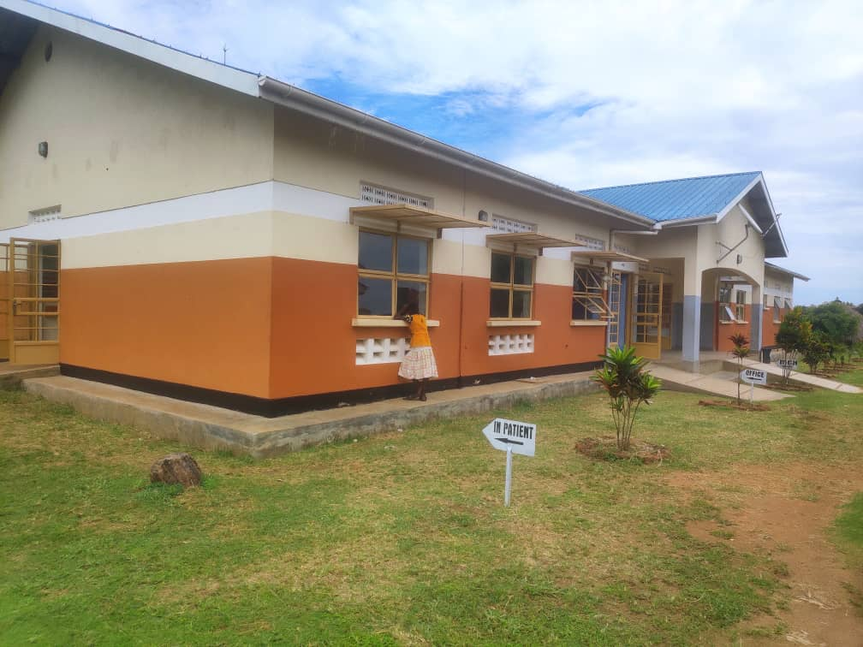
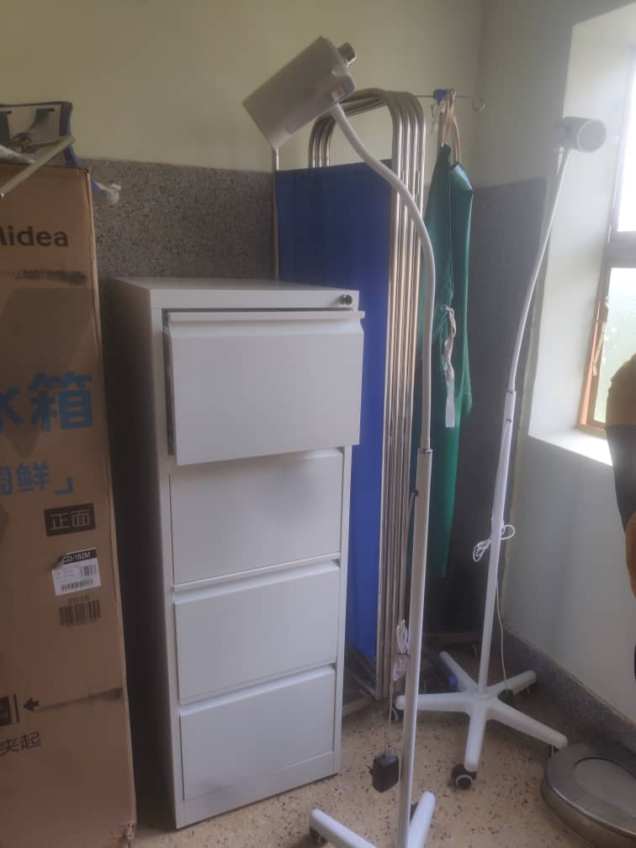
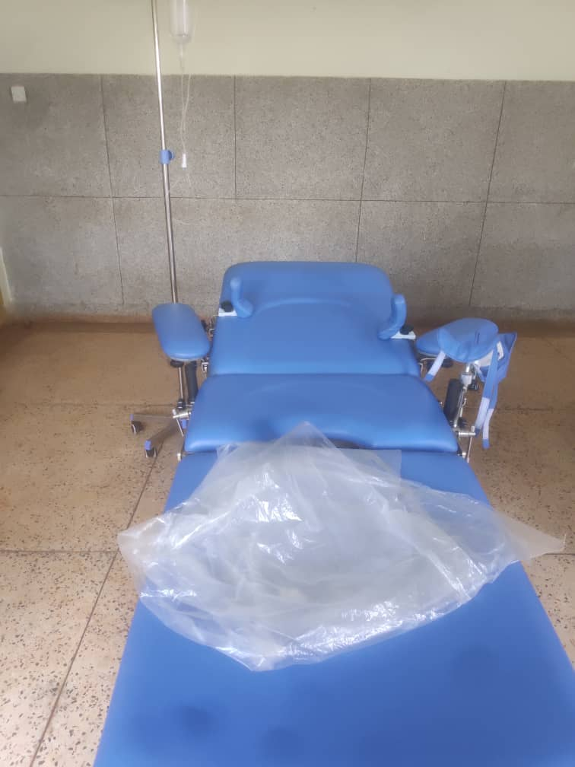

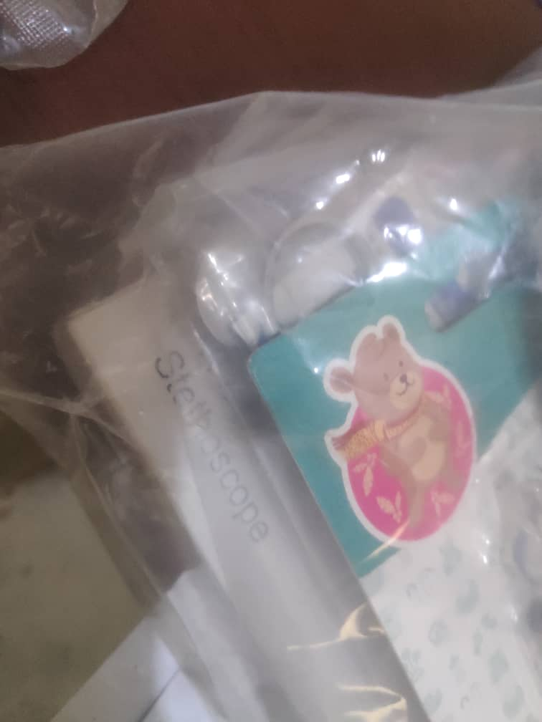
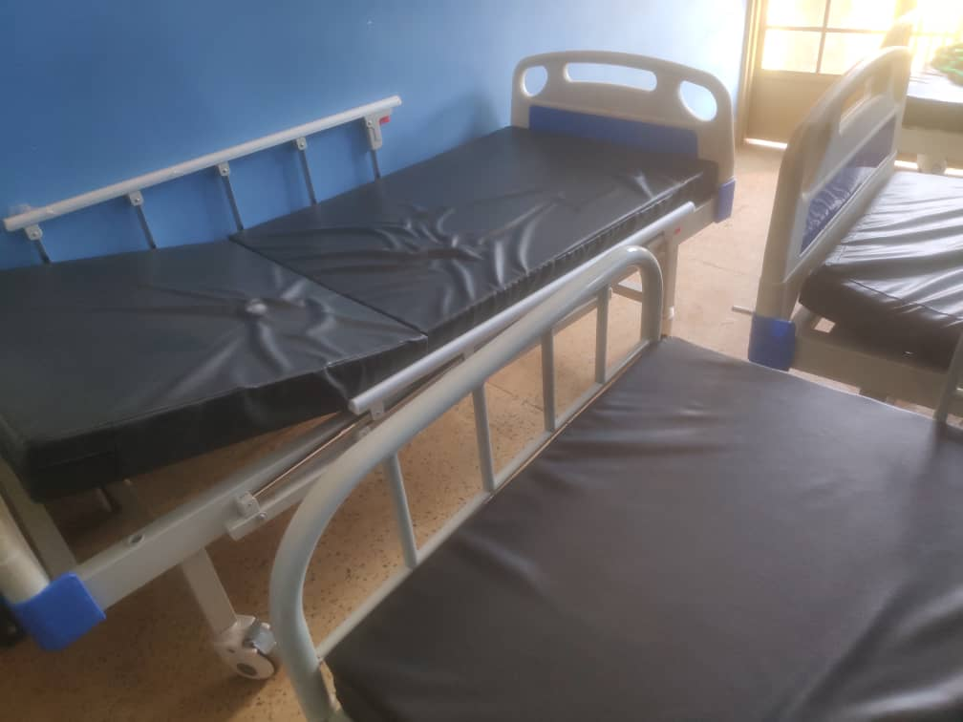
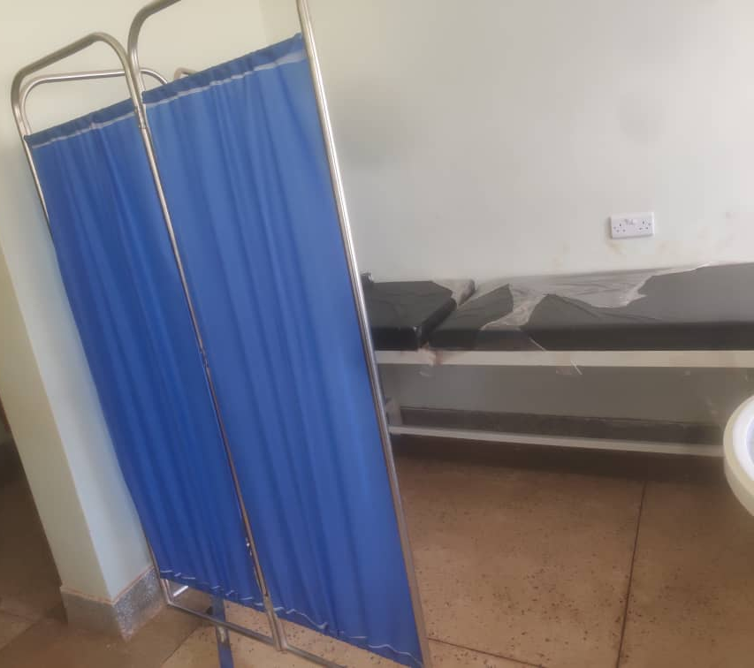

- GOT APWOYO HEALTH CENTRE III | NWOYA DISTRICT LOCAL GOVERNMENT
Executive Summary
This report presents the field audit findings and verified physical asset inventory for Got Apwoyo Health Centre III, located in Got Apwoyo Sub-County, Nwoya District Local Government, executed under the Uganda Intergovernmental Fiscal Transfers (UgIFT) Programme.
Got Apwoyo Health Centre III is highly functional and well-equipped under UgIFT support, significantly reducing patient referrals and boosting service quality. However, operational delivery is constrained by two major factors: staff unfamiliarity with the operation of certain advanced medical machines, and unreliable electrical power supply.
Field Findings
- The main building structures are in good condition and fully functional that is the OPD, In-patient, Maternity and offices (Civil Buildings & Sanitation)
- Most of the available medical equipment, and laboratory instruments are functional.
- All assets are not engraved
- Improved service delivery: Modern clinical gear has enhanced diagnostic precision, reduced emergency referrals, and boosted patient turnout.
- Operational expansion: Community trust and patient volume have increased markedly due to the comprehensive delivery of diagnostic and maternal equipment.
Qualitative Assessment
Key findings from interviews with health facility in-charges regarding UgIFT program implementation, asset maintenance, operational impact, and service bottlenecks:
The asset register maintained at the facility captures item quantities but lacks unit purchase costs.
Service Delivery Impact
- Primary health expansion: Modern medical equipment has significantly increased patient volume and improved maternal and child health services in the community.
- Referral reduction: Modern clinical equipment has dramatically reduced emergency referrals and expanded local maternal/child health capacity.
- Operational utility & community trust: Medical equipment and facilities in use have boosted outpatient/inpatient admissions and community confidence in local healthcare delivery.
Record keeping
- Incomplete asset ledger: The facility ledger lists delivered item quantities accurately but lacks financial purchase values.
Repair and maintenance
- Maintenance escalation: Breakdowns are reported to CAO, DHO, and Gulu Regional Referral Hospital maintenance engineers for scheduled servicing.
- Escalation to DHO: Equipment breakdown logs are updated regularly and submitted to the District Health Officer and Gulu RRH engineers.
Challenges
- Orientation needs: Healthcare personnel require comprehensive orientation and hands-on training on advanced diagnostic and therapeutic equipment.
- Power supply fluctuation: Unstable electricity hampers routine usage of motorized suction units, oxygen concentrators, and centrifuges.
Recommendations
- Solar / grid power stabilization: Coordinate with Nwoya DLG and MoH to install a heavy-duty solar backup system or power stabilizer to ensure 24/7 power for oxygen machines.
- Electrical wiring audit: Verify facility electrical circuitry to prevent power surges from damaging sensitive medical electronics.
- Medical equipment orientation: Organize urgent clinical training sessions with Ministry of Health equipment
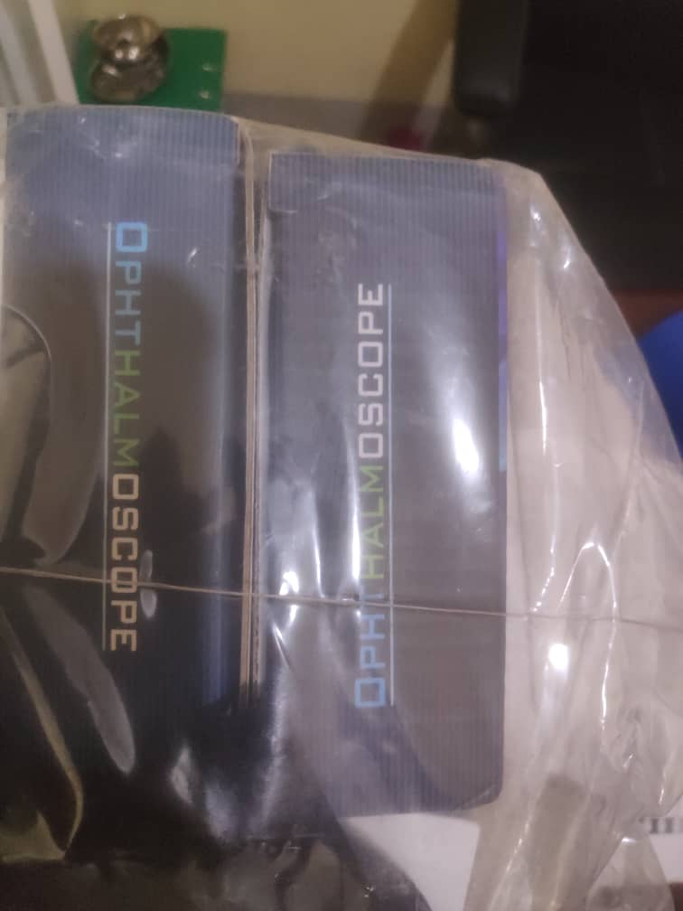
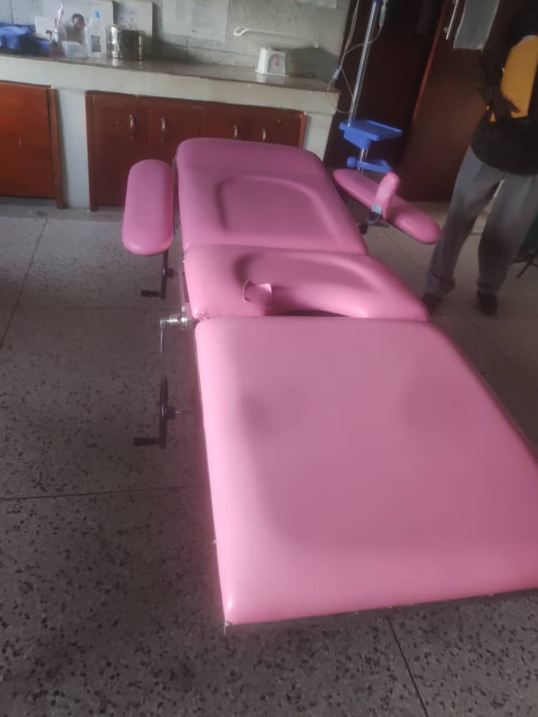

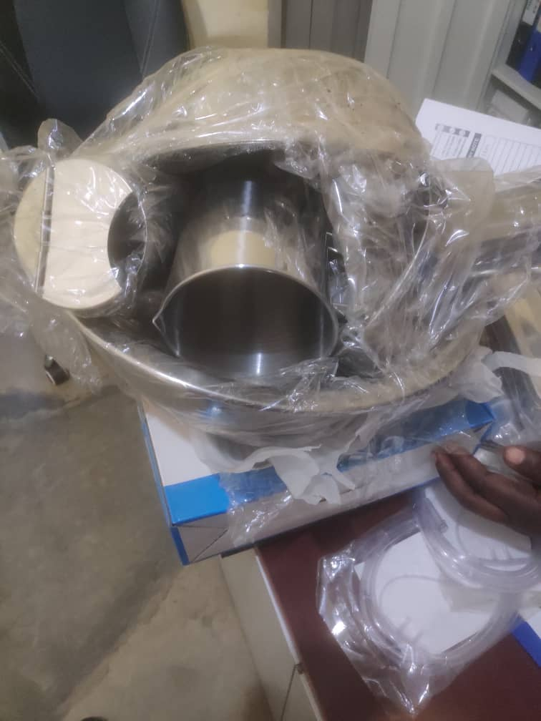
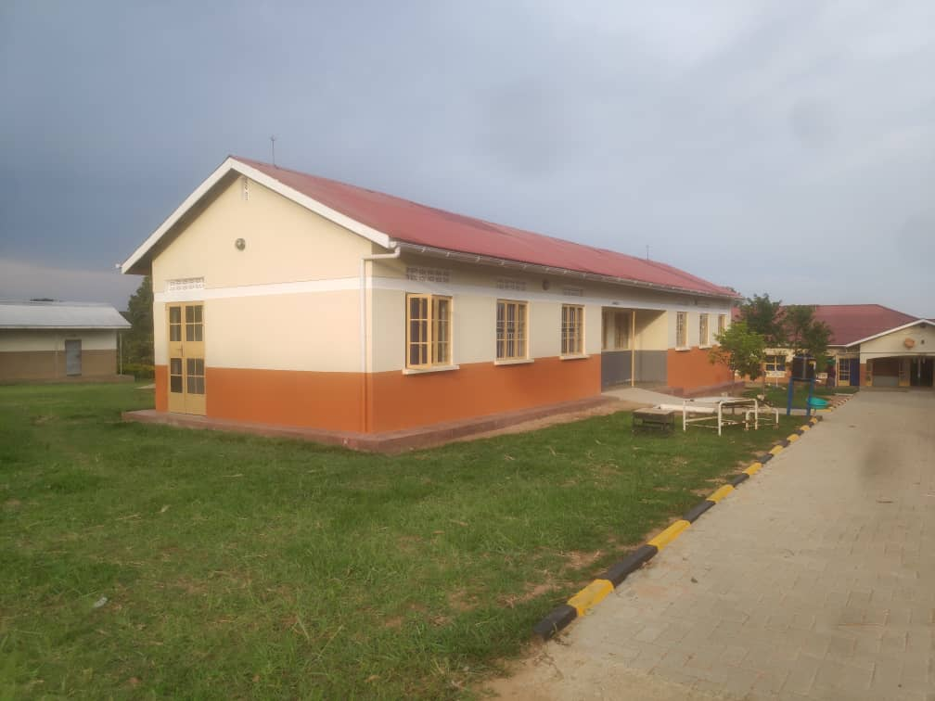

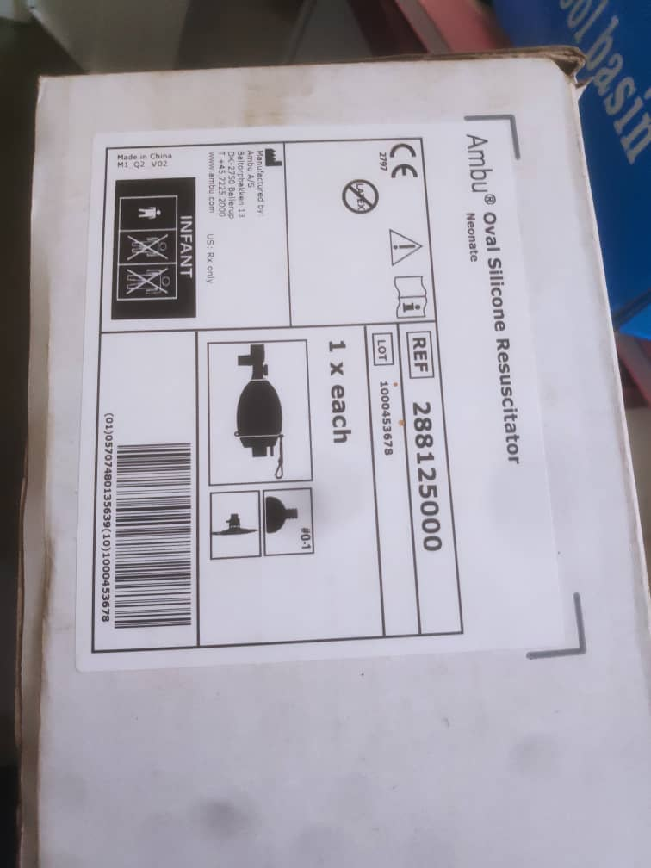
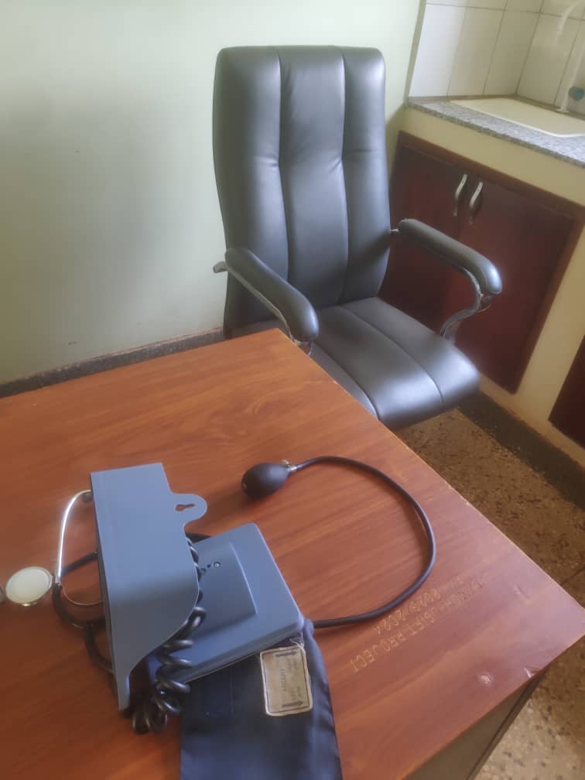

Report compiled by:
Isah Lukwago and Stella Male

